Energy

A 25kW Hybrid Solar System generates an average of 3000 units per month and has 150 square meter area for installation. This costs £19,810.97 and generate average 3000 units per month through-out the year.

Peru is known for their consistent and high-intensity sun that provides a valuable source of energy. Through researching renewable methods for generating energy, the conclusion came to solar energy being the most optimal. The abundance of sunlight in Lobitos causes solar energy to be the appropriate alternative for generating electricity, without emitting greenhouse gases. This is further supported by the graph below that shows the monthly recordings of the daily solar energy incident on a surface over a wide area.

Solar energy in sunlight is converted into electrical energy through photovoltaic cells found in the solar panels. Each solar cell is comprised of a PN junction of a silicon semi-conductor that emits an electric field. Once a photon of sunlight shines on a solar panel, an electron is ejected from the junction and produces electricity. This is connected to main power grid to allow the electricity to be distributed amongst the machines. This is connected to main power grid that allows the electricity to be distributed amongst the machines.

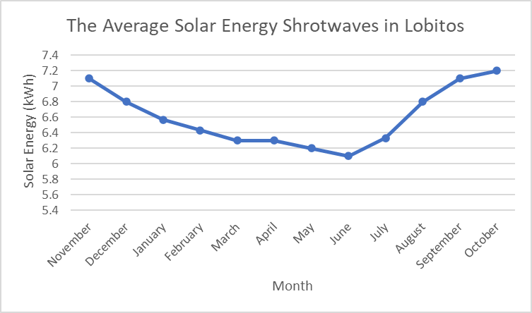

Figure 1: *The average daily shortwave solar energy reaching the ground per square meter*

The results show that sunlight is consistent through the seasons in Lobitos. This is evident by the varying solar energy averages that range from 7.2kWh to 6.1kWh. Therefore, the solar energy can effectively be transmitted through the hybrid solar system into an electric energy output that powers the machines. The decision for the hybrid solar system is due to the inclusion of a hybrid inverter. This converts the direct current from the solar panel to alternating for the machines, while additionally charging the battery back-up system. Furthermore, the backup capability reduces the demand for power because energy can still be distributed, even when no light is present for the solar panels to produce the energy.